[1] determines that the average wind speed monitored via an anemometer is $\frac{n}{2}×{2πR}/T$, where $n$ is the number of pulses over a period $T$ detected from the anemometer by the microcontroller, and $R$ is “the radius from the pivot to the edge of a cup” [1], [2]. However, a real anemometer always contain a parameter called the anemometer factor $K$ as demostrated by [3]. However, since the determination of the anemometer factor requires a deep study on the aerodynamic characteristics of the cup anemometer itself, this thesis shall only take the basic field test results of the sensor for designing the software related to this wind speed sensor.

The test for the 3-cup anemometer behaviour involves an MFP107 Axial Fan Module by TecQuipment. The fan module has protective grilles at both ends of the duct, so the anemometer is set up just outside the duct to catch the exiting air whose flow is assumed to be uniform. The slide-valve is opened to 100% for maximum air flow. The fan speed is increased manually via the control panel by a step of 200 revolutions per minute; the volume metric flow rate is measured by the fan module and recorded via software once per second. For each fan speed value, an STM32F103CBT6 microcontroller counts the number of pulses from the anemometer for 20 seconds and displays on the Serial Monitor at the end of each sampling window. The mean volume metric flow rate of the fan module and the pulse count by the microcontroller are then recorded manually to a spreadsheet to be processed later.

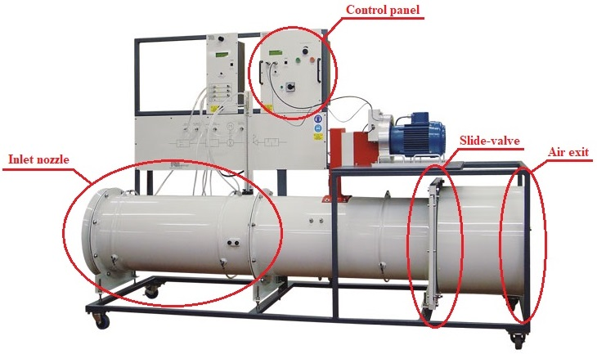

Figure 1. TecQuipment Axial Fan Module – MFP107 [4]

Although the MFP107 Axial Fan Module does not monitor the air speed through the duct directly, its built-in sensors still read the volume metric flow rate, which could still be used to calculate the air speed by dividing it by the cross-section of the duct, whose diameter is 40cm. The test run result is as follows.

|  |  |  |  |  |
| --- | --- | --- | --- | --- |
| **Duct diameter** | **D = 40 cm** |  | **R = 9.2 cm** | **T = 20 s** |
| **Mean flow rate** *fmean***, (m3/s)** | **Machine wind speed** *Vm***, (m/s)** | **Pulse count *n*** | **Read wind speed** *Vs***, (m/s)** | **Factor =** *Vm***/***Vs* |
| 0.85 | 6.764085081 | 30 | 0.433539786 | 15.60199386 |
| 0.91 | 7.241549911 | 55 | 0.794822941 | 9.110896948 |
| 0.958 | 7.623521774 | 92 | 1.329522011 | 5.734032014 |
| 1.022 | 8.132817592 | 135 | 1.950929038 | 4.168689601 |
| 1.14 | 9.071831756 | 176 | 2.543433412 | 3.566765976 |
| 1.33 | 10.58380372 | 254 | 3.670636856 | 2.88336987 |
| 1.44 | 11.4591559 | 289 | 4.176433274 | 2.743766068 |
| 1.56 | 12.41408556 | 329 | 4.754486322 | 2.611025613 |
| 1.65 | 13.13028281 | 370 | 5.346990696 | 2.455639733 |
| 1.78 | 14.16478994 | 383 | 5.534857937 | 2.559196658 |
| 1.9 | 15.11971959 | 437 | 6.315229552 | 2.394167855 |
| 2.03 | 16.15422672 | 505 | 7.297919734 | 2.213538558 |
| 2.15 | 17.10915638 | 538 | 7.774813499 | 2.200587369 |

[1] H. N. Do, “Conceptual Design of an Autonomous Wireless Agrometeorology Station,” 2023.

[2] Raspberry Pi Foundation, “Build your own weather station.” https://projects.raspberrypi.org/en/projects/build-your-own-weather-station/0.

[3] S. Pindado, J. Cubas, and F. Sorribes-Palmer, “The Cup Anemometer, a Fundamental Meteorological Instrument for the Wind Energy Industry. Research at the IDR/UPM Institute,” *Sensors*, vol. 14, no. 11, pp. 21418–21452, Nov. 2014, doi: 10.3390/s141121418.

[4] AYVA Educational Solutions, “TecQuipment Axial Fan Module – MFP107.” https://www.ayva.ca/eng/product/axial-fan-module/.